Recipe Book Project.

1In the Main Branch, a text file has been created with recipes, and committed to local repo.

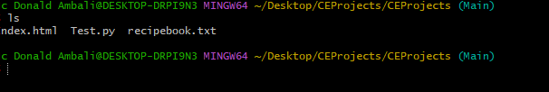

2. A copy of the recipe book file has been copied to dev git branch , done 1 new insertion and committed.

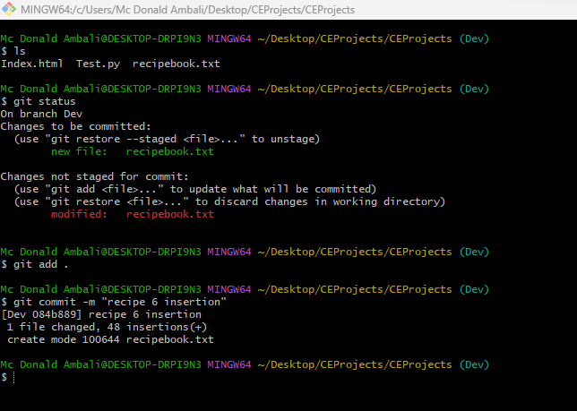

3. Merging recipe book in Dev branch with one in Main

